Important to know when you have no 120V or no 12V in your RV.

Converter (picture below) converts 120V to 12V to charge the RV batteries when plugged into a 120V outlet or campground pedestal. If warm the fan at the end of the converter will turn on and later stop. That is normal.

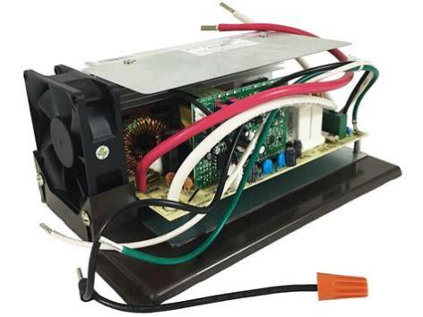

Our converter is Progressive Dynamics PD4655V Inteli-Power 4600 Series Converter/Charger with Charge Wizard - 55 Amp

The converter is wired to a 120V breaker.

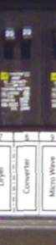

Converter’s thin black wire is connected to a 120V breaker (ours is labelled breaker B7) (middle side of the pic below). The green and white wires are connected to 120V busbars. (left side of pic below). Converter’s thick white and red wires are connected to the 12V fuse side (right side of pic below). Converter is sitting in the bottom (pic below). Pic below is your RV’s distribution panel.

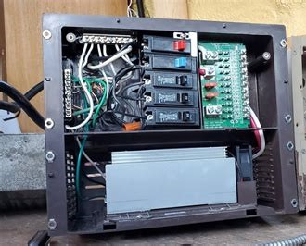

When the RV is plugged into 120V outlet or pedestal and the converter’s 120V breaker is not tripped it will send some of the 120V to charge the 12V batteries. The 12V batteries allows the slide to open, the lights on, the furnace etc.

If you have no 120V or 12V you need to test it and identify the issue.

Outside - no 120V:

If you have one - plug surge protector (pics below) into 120V campground pedestal, to see if there is 120V present.Surge protector will display voltage in LED colors or a light will be on. If no display or light on surge protector contact campground.

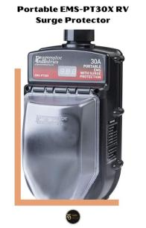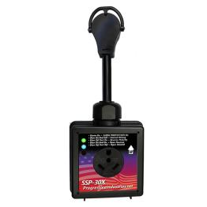

Outside - no 12V:

Check battery voltage - see if above 12V. Multi meter (see pic below) on DC (V…) usually at 20, black lead on negative battery post, red lead on positive battery post. Should be over 12V. If not charge battery to 100% charged. Retest when fully charged.

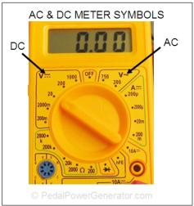 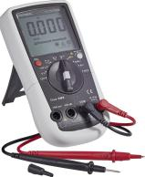

Take battery tester, (pic below) connect red clip to positive battery post, connect black clip to negative battery post. Battery tester will display voltage. Press and hold red button - this puts a load or a draw on the battery. Needle will now show if battery is OK condition, weak or bad condition. If weak or bad buy new battery.

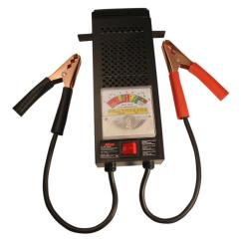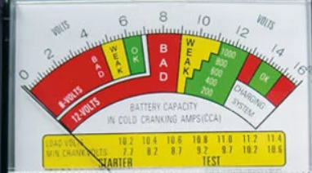

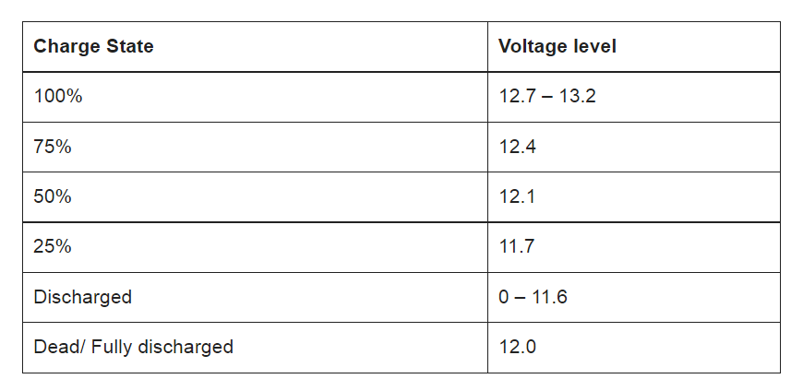

If battery is good, then check ground on RV.

Battery is grounded to the RV frame. Follow the negative wire from your battery to the frame of the RV. Multi meter on DC (V…)Take red lead of multi meter to battery positive, black lead on bolt to where the battery is grounded to the frame, should be above 12V.

If not, remove ground bolt, remove any rusted parts, put dielectric grease and put a new ground bolt into frame. Retest voltage.

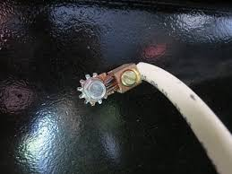

If good then continue to auto reset breakers should be same voltage as battery and battery to ground.

Auto reset breakers (pic below) will be near the battery, usually attached to the frame, some at the front of the RV, some under the front of the RV.

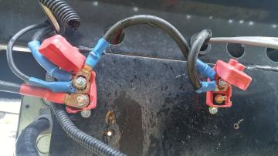

Multi meter set to DC (V …), usually 20, black lead touching a bolt attached to the RV frame (called ground) and without moving black lead, with red lead touch each post of the auto reset breakers, one at a time (pic above). Each post should be same volt as battery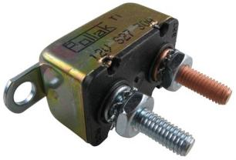voltage.

If voltage on auto reset breakers substantially lower than battery voltage you may have a battery disconnect switch (pic below) turned on. Find battery disconnect switch and turn it to off.

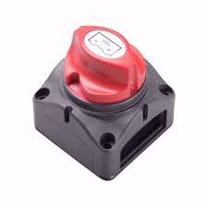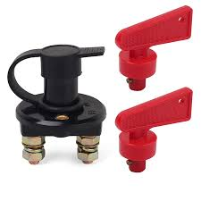

If old model RV with manual breaker may need to reset button on side of breaker. 

INSIDE: (if converter is toast, there is no charging of the batteries, could still have 12V but lights dimming because battery is getting low)

Open distribution panel and remove cover. On the bottom is the converter.

If breaker is tripped to converter (B7 for us) turn it back on. If breaker keeps tripping converter is toast.



Take multi meter, turn to AC (V squiggly line), set at 200, connect black lead to a copper wire/ground or to copper wire busbar, red lead to the screw on each breaker. See if you have 120V. (called ground to power). If 120V at other breakers but not at breaker for converter - converter is toast.

Take multi meter, turn to AC (V squiggly line), set at 200,connect black lead to a white wire/neutral or to white wire busbar, red lead to the screw on each breaker. See if you have 120V. (called neutral to power). If 120V at other breakers but not at breaker for converter - converter is toast.

In ours skinny wires from converter to 120V breaker and busbars, fat wires from converter to battery.

Take multi meter, turn to DC (V …), set at 20 - fat wires - black lead on white wire, red lead on black wire. Should be about 13.6V. If way below 13.6V converter could be on it’s last leg. (See NOTE below).

In our case, left side screws 1 and 3 is wires from converter, screws 2 and 4 are wires to batteries.

Take multi meter, turn to DC (V …), usually 20, put black lead on copper wire busbar, test each 12V connection by touching red lead on screw to the right of fuse. Should have 13.6V for good converter.If way below 13.6V converter could be on it’s last leg. (See NOTE below).

On some RV white wire is negative, red wire is positive - on ours white wire is negative, black wire is positive.

NOTE: Can put multi meter on DC side - get reading 13.6V then turn off converter breaker. If voltage drops substantially - converter is good.

If converter appears bad, need to check their fuses first. Some converters have fuses on the side. Some 30 amps some 40 amps. Some converter have fuses in the middle of the distribution panel.

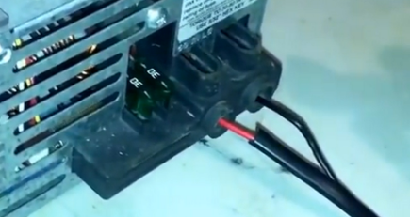 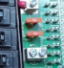

FYI - 12V power comes in to one side of fuse and goes out to the other side of fuse.

With test light - connect test light clip to a positive battery source and touch metal prong on metal sides of each fuse. Test light should light up on both sides. If test light doesn’t light up changes fuses and try again.

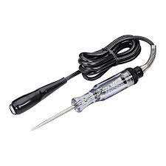 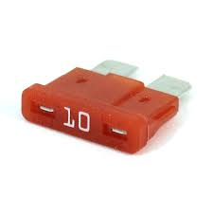

If just a 120V outlet not working:

Testing 120V receptacles

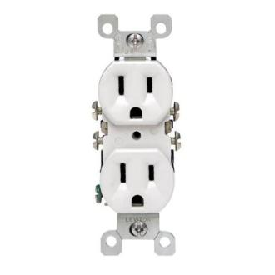

Long side is neutral, short side is line or hot. Round is ground.

Multi meter to AC (V squiggly line) set at 200 black lead into long side first, red lead into short side - sb 120V. Red lead into short side, black lead into round sb 120V. called hot to ground.Black lead to long side, red lead to round sb 0V.

If no 120V reading, check outdoor GFI plugs. It is usually a string of 3-4 of them on the same wires. Could be outside, near bathroom sink, near kitchen sink.

